# Acceptance Criteria Testing

## Story ID 8

User Story: As a customer I want to be able to book new packages for pickup so that I can ship my items to the receiver.

* I can enter my details (shipper) or use the current details stored on my account & enter the recipient details & enter the package details (weight, size etc).

I can enter my details 🡪 Automatically entered from account details

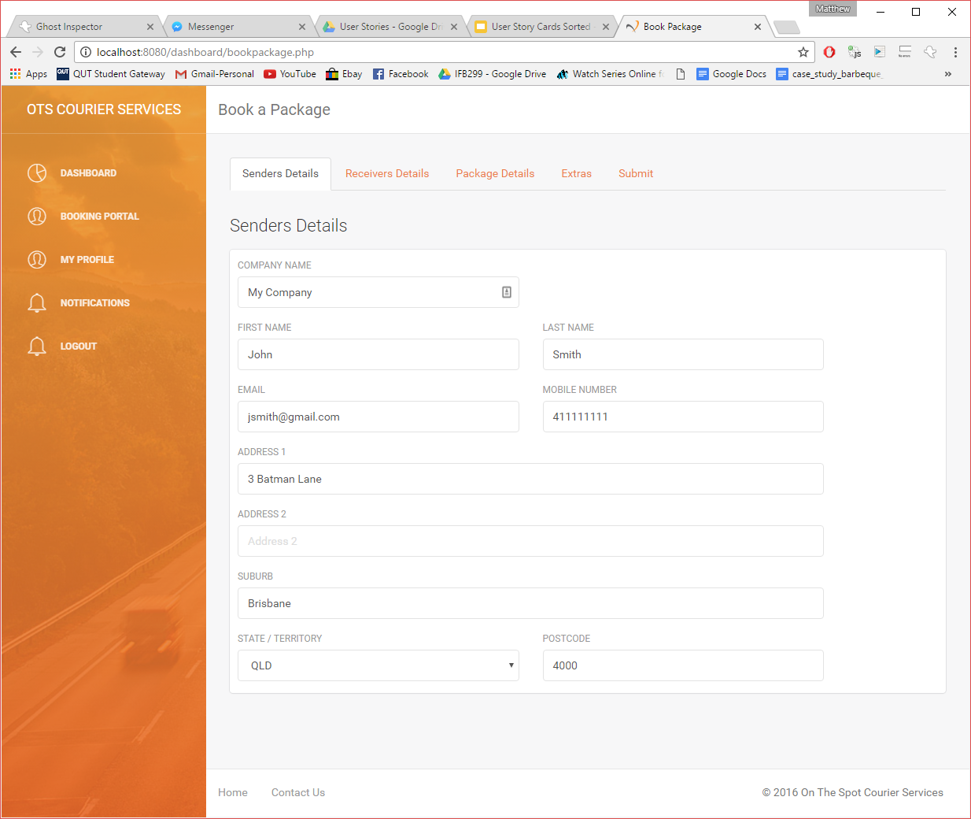

I can enter recipient details

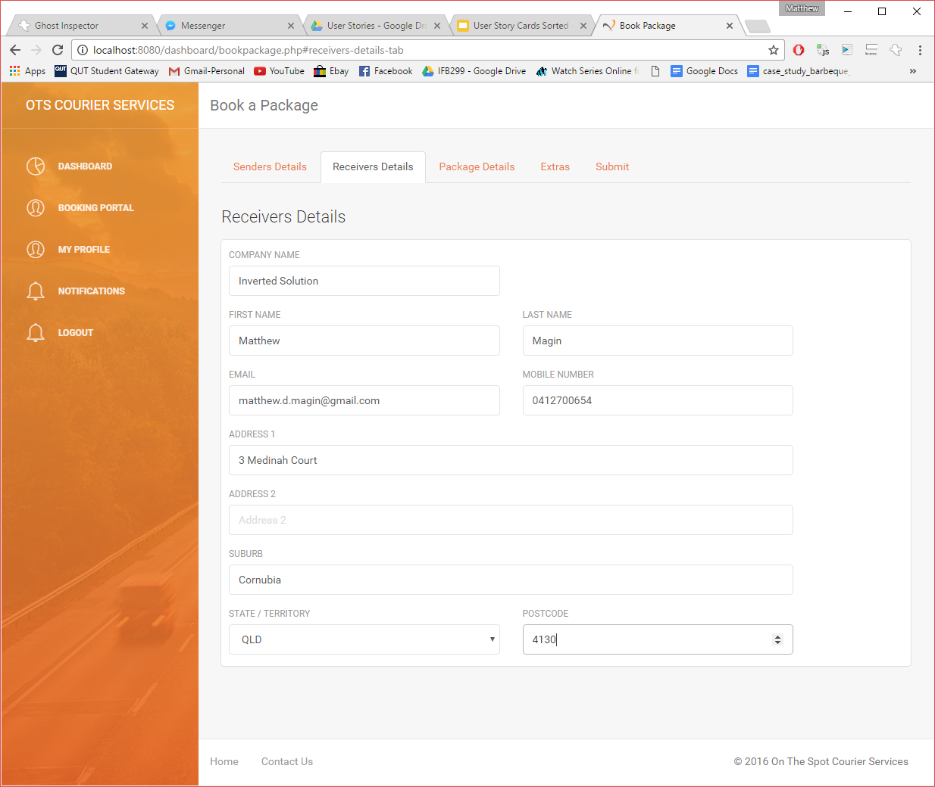

I can enter package details

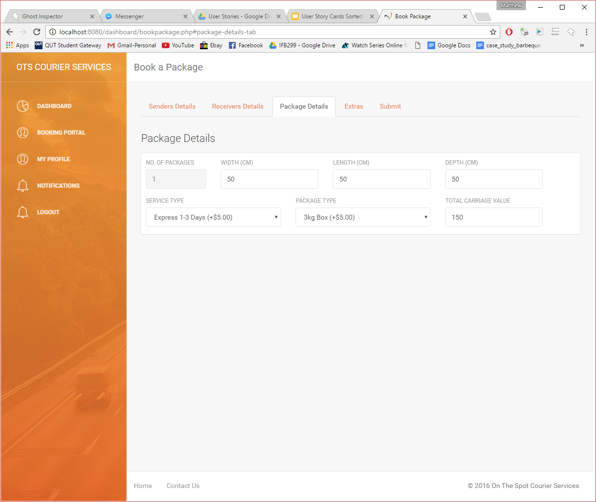

* I can select the type of payment on pickup and get the cost of shipping).

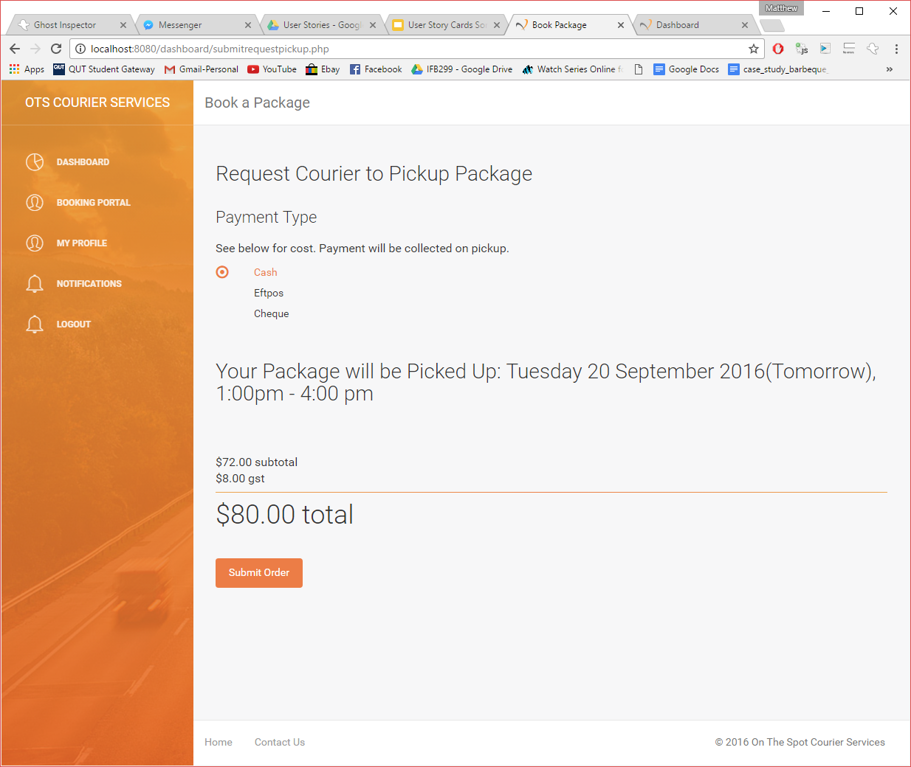

* I can enter a time that the package can be picked up (or asap).

NOT IMPLEMENTED 🡪 AFTER BOOKING A PACKAGE, THE SYSTEM WILL GENERATE A PICKUP TIME 🡪 CLIENTS UNDERSTAND THIS AND AGREE WITH THIS.

* Before booking I get the cost to ship the package so that I can have the money / payment type ready for when the driver picks up the package.



* I get a confirmation that the package has been booked.

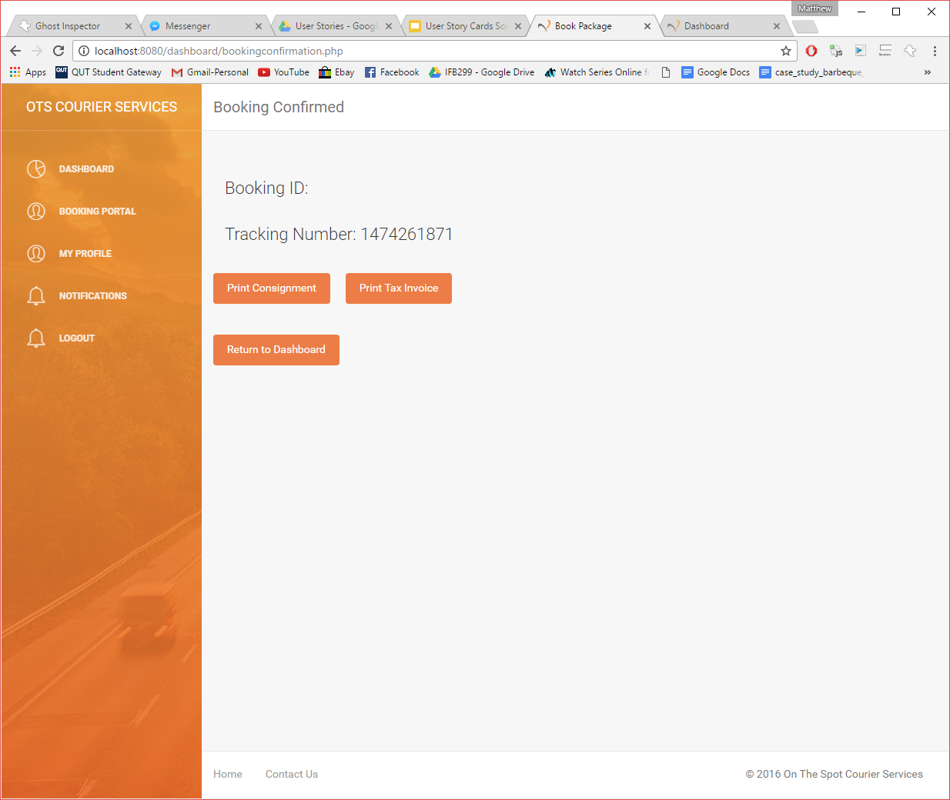

Confirmation Page

Error: Not outputting booking ID 🡪 will be placed in the backlog and fixed during Sprint 3.

* I can see the package in the pending packages section

